5-1
Mlle Amanda Bulger
EMTS
Parent Info
Welcome to ÉMTS! I am excited to work in team with you!

Bonjour! Hello!

I cannot tell you how thrilled I am to be a part of the amazing school community here at Mother Teresa and back inside the building again getting to see your kids faces everyday! I’m beyond excited to have the chance to teach some siblings of former students I had and work again with you amazing parents. I’m also excited to welcome some new faces I’m not as familiar with and work with some new parents.
I am a strong believer that we are working in team. It takes a united front and many hands on board to make your child’s education the best it can be. I so look forward to working closely with your child and the rest of the staff here and you to help your child grow and learn. I continue to strongly focus on remembering that each year will be a year where I need to have even more grace and patience as we’re faced with many unknowns and new ways of doing things with the students coming to new school. I know there will be challenges and mistakes made this year from all of us. Please be extra patient with me and I promise to do my best to show that same level of patience with your kids and you :).
Please remember that you can always contact me with any questions or concerns. I will do my very best to reply to emails within 24 hours. If you would prefer a phone chat, send me an email with your number and we can arrange a time to talk.

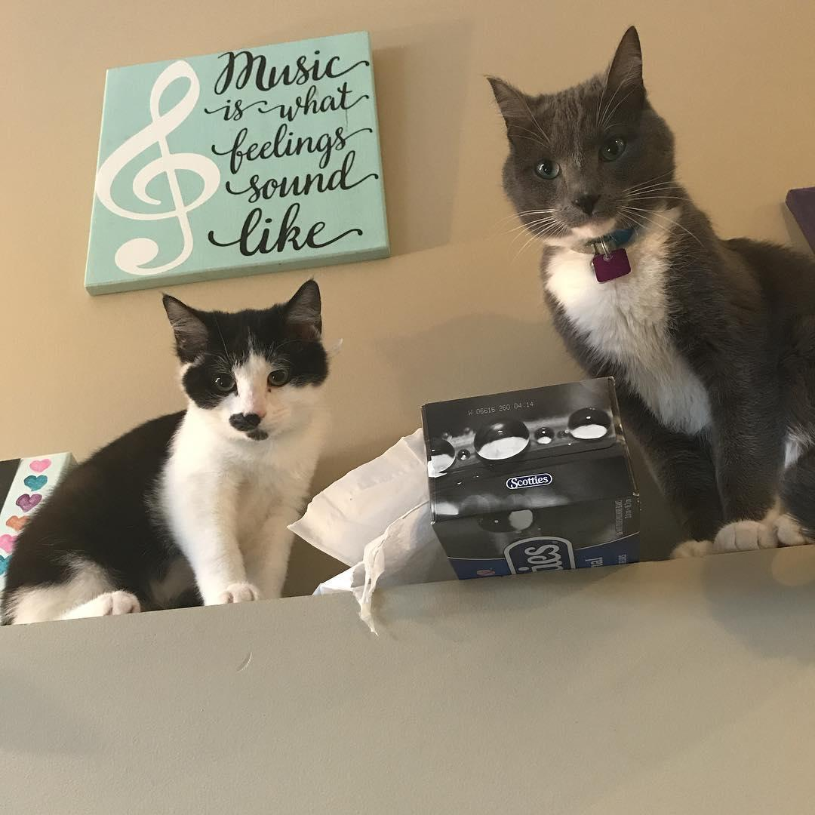
A little info about me
I am currently entering into my 14th year of teaching(time flies when you’re loving what you’re doing!). I grew up in a little town called Morinville just north of Edmonton. I started my teaching career in a little town called Mallaig teaching a 1/2 French Immersion class. I then hopped to Morinville, Ft. Saskatchewan and Drayton Valley teaching K-1 before finding my happy place here in Sylvan. I spent 5 years at Ecole Our Lady of the Rosary teaching grade 2 French Immersion.

In my spare time I love singing, watching hockey(I’m a huge Oilers fan. Can’t wait for some friendly rivalry with some of my Flames fan in the class), reading, spending time with my family and friends, going to concerts and loving my 2 cats(the descent to crazy cat lady has begun ;) )

Nut Safe: We are a nut safe facility. We have students with serious nut allergies in our school. Please refrain from sending anything with nuts in it.

Expectations:
- Respect for everyone and everything
- Have a growth-mindset; giving 100% effort
- Speak French
Class dojo points:
- Points will be given for speaking French and positive behaviors like staying on task, working hard, participating, etc..
- If heard speaking English or making poor choices,I remove points
- When student earns a hundred points they can choose a prize
- Can be a bit anxious at the beginning of the year, but the results are incredible! Fluent, confident French speaking kids!
- If there are worries or frustrations with your children over this please let me know!

Library: A reminder that our school runs on a 5 Day rotation schedule. What this means is that our library will not be on a set same day every week. I will be sure to include it in my week at glance, and as our agenda the night before so kids know to pack their library books. Library most likely will be starting mid September. Kids will be taking 2 French books and 2 English books with the expectations that 1 of each language book is left at school for silent reading time.
Homework: I know that your lives are busy with after school activities. I do not plan on bombarding your child with hours of homework everyday. I will expect home reading to be done every night in both languages.My suggestion is to do 3 nights in French and 2 English. Or maybe 10-15 mins of each language per night. I will also be getting your children to work on their math multiplication facts and we will have Multiplication Fact quizzes almost each week. There will also be assignments for various subjects sent home at times. Please let me know if you find the homework load too much. When we have a quiz or test coming up I will be sure to let you know ahead of time so your child can study. I won’t be starting with homework until the middle of September.

Hot Lunch: More information will be sent out a little later regarding optional ordering of hot lunches from various food establishments here in town.
Lunch: Students will remain with their class in the classroom this year. We don’t have access to microwaves so please don’t send any warm-ups.
Criminal Record Checks: Please remember that to volunteer, in any capacity, we must have a copy of your criminal record check. Any new criminal record check must be submitted within 30 days of issue. This can take a bit of time to get, might be an idea to get soon.

AGENDAS
Your child’s agenda and our website is FULL of information regarding EMTS and expectations. I strongly suggest to take a moment to read through the agenda’s first pages. Your child will copy our message every day of upcoming events, due dates, etc. We haven’t received them yet.

NEWSLETTERS and SCHOOL EVENTS
Tara Spotter is a rock star!! She is our communication secretary at school, the first lovely smile you see in the office and a true gem! I am so grateful for all of the time she spends each week to create and send the WEEK-AT-A-GLANCE. Her efforts will keep you up to date on school information each week. I will do my best not to bombard you with information that she has already sent to you. Any information that is specific to our class, I will update and have on my class website(https://750400819472016566.weebly.com/). I will be creating a week at a glance on this class website every week to keep you informed of happenings in our class. This will take the place of a monthly newsletter. Bookmark this webpage as I upload lots of info and homework help on here.
SOCIAL MEDIA
École Mother Teresa School has over 500 students! This makes for a lot of activities and events. I strongly encourage you to follow us on Twitter and Facebook.

EMAIL
You will be receiving emails from Tara Spotter. Thanks for taking the time to read through them. She is great at updating all our community on the events happening within our school.
REPORT CARDS
We are now switching to Schoology as our online and live reporting system. It’s a new system for our school so please be patient as we navigate this new system. It will be like EDSBY/Powerschool in that you will get live reporting and updates on your child’s progress
5 DAY TIMETABLE
We have now switched to 5 Day rotation time table.
Day 1: Monday, Aug 31 and Tuesday, September 1st(Due to staggered entry)
Day 2: Tuesday, Sept 5th(First day for all students together and Welcome/Feast of Mother Teresa)
Day 3: Wednesday, Sept 6th
Day 4: Thursday, Sept 7th
Day 5: Friday, Sept 8th
And so on so forth

